WINNEBAGO COUNTY

VETERINARY SCIENCE PROJECT RECORD FOR 20

Things I plan to do and learn this year in this project are: (complete this box between Jan. 1 — May 1) | Check When Done

Describe what you learned and accomplished in this project this year:
What veterinary science project related skill(s)

would you like to learn or still improve?

Ways You Received Help This Year Include:
(check all that apply)
Exhibits in This Project:
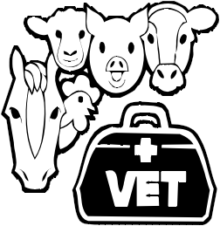Item Placing
(additional page may be added)

Attended project training offered by my club
Attended project training offered at the county level
Attended project training offered at District or State Level
Guidance from 4-H Leader/4-H Club
Guidance from Parent/Guardian/Other Adult
Reading and use of 4-H project guides
Reading and use of literature, books, audio visual resources
Own knowledge
Help from friends/other youth
Other (describe)

Place photos, drawings, or other related items about your project here:

What did you enjoy most about the project?

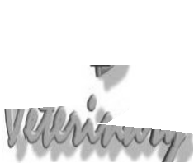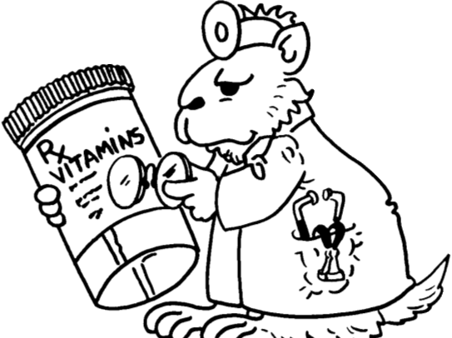List at least 2 veterinary science related careers that you can identify.

What did you enjoy least about the project?

Are you interested in a career related to veterinary science?
Yes_ No_ Maybe_

Project Worth Statement

Has this project been worthwhile to you? Why or why not?

Revised 11/2006

