WINNEBAGO COUNTY

SCIENCE DISCOVERY PROJECT RECORD FOR 20

Things I plan to do and learn this year in this project are:  (complete this box between Jan. 1 — May 1) | Check When Done

Explain why you selected this project and how you feel about what you accomplished.

Ways You Received Help This Year Include:
(check all that apply)
Exhibits in This Project:
Item Placing
(additional page may be added)

Attended project training offered by my club
Attended project training offered at the county level
Attended project training offered at District or State Level
Guidance from 4-H Leader/4-H Club
Guidance from Parent/Guardian/Other Adult
Reading and use of 4-H project guides
Reading and use of literature, books, audio visual resources
Own knowledge
Help from friends/other youth
Other (describe)

What did you learn or enjoy in the project this year?

What project related skill(s) would you like to learn or improve?

List at least 2 industry related careers that you can identify.

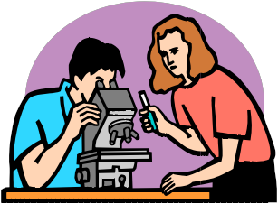Are your family or friends interested in this project with you? Yes No

If yes, what do you do together?

Are you interested in a career related to this project?

Yes_ No_ Maybe_

Project Worth Statement

Has this project been worthwhile to you? Why or why not?

Revised 11/2006

