WINNEBAGO COUNTY

PET PROJECT RECORD FOR 20

Things I plan to do and learn this year in this project are: (complete this box between Jan. 1 — May 1) | Check When Done

Information About Your Pet

Name(s) of Pet(s) Sex: Male Female

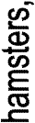Age of Pet
Date of Birth/Purchased Where Obtained

Breed or Description Tell how you got your pet. If you picked it out, why did you pick this pet?

Who is mostly responsible to care for this pet?

Who helps out?

Describe food, supplies, and health care needed for your pet:

Place photos, drawings, or other related items about your pet on an additional page.

Ways You Received Help This Year Include:
(check all that apply)
Exhibits in This Project:
Item Placing
(additional page may be added)

Attended project training offered by my club
Attended project training offered at the county level
Attended project training offered at District or State Level
Guidance from 4-H Leader/4-H Club
Guidance from Parent/Guardian/Other Adult
Reading and use of 4-H project guides
Reading and use of literature, books, audio visual resources
Own knowledge
Help from friends/other youth
Other (describe)

Explain why you selected this project and how you feel about what you accomplished.

What did you learn or enjoy in the project this year?

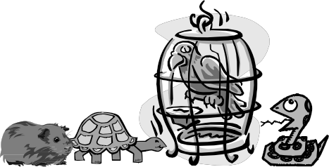List at least 2 pet industry related careers that you can identify.

What project related skill(s) would you like to learn or improve?

Are you interested in a career related to the pet industry?
Yes_ No_ Maybe_

Project Worth Statement

Has this project been worthwhile to you? Why or why not?

Revised 11/2006

