WINNEBAGO COUNTY

HEALTH PROJECT RECORD FOR 20
Things I plan to do and learn this year in this project are: (complete this box between Jan. 1 — May 1) | Check When Done

Which aspect of wellness did you work on the most this year?

Physical Emotional

Intellectual Environment

Social

Why?

Ways You Received Help This Year Include:
(check all that apply)

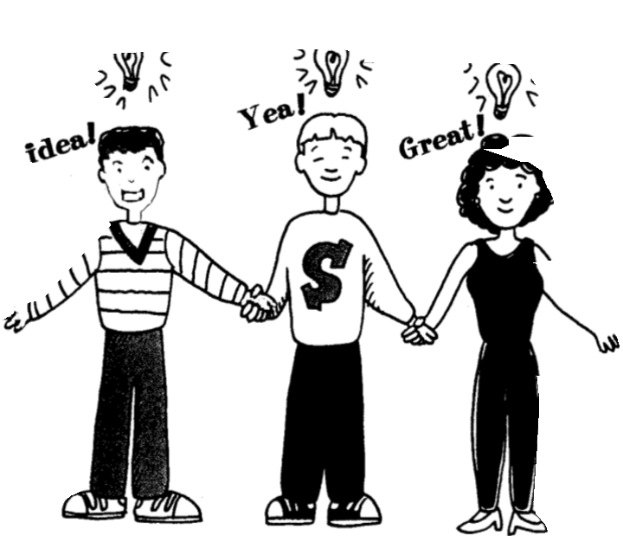

Exhibits in This Project:
Item Placing
(additional page may be added)

Attended project training offered by my club
Attended project training offered at the county level
Attended project training offered at District or State Level
Guidance from 4-H Leader/4-H Club
Guidance from Parent/Guardian/Other Adult
Reading and use of 4-H project guides
Reading and use of literature, books, audio visual resources
Own knowledge
Help from friends/other youth
Other (describe)

Choose 1 exhibit you made. Explain what you did and what you learned from making the exhibit.

Exhibit:

List at least 2 health industry related careers that you can identify.

Are you interested in a career related to the health industry?
Yes_ No_ Maybe_

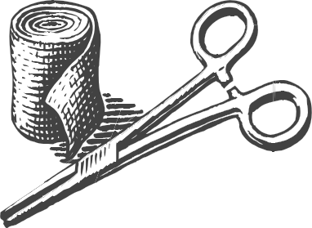

What health project related skill(s) do you still want to learn or improve?

Project Worth Statement

Has this project been worthwhile to you? Why or why not?

Revised 11/2006

