WINNEBAGO COUNTY

GEOSPATIAL PROJECT RECORD FOR 20

Things I plan to do and learn this year in this project are: (complete this box between Jan. 1 — May 1) | Check When Done

CHECK SKILLS LEARNED OR IMPROVED

Map Reading
Learning to make maps

Identify location of places
Using maps and other geographic tools Analyzing the spatial organization of
people, places, environments Actively participates in team activities Decision-making
Listening Critical thinking Problem solving Organizing information Applying technology
Collecting and analyzing data Interpreting data/information
Manipulates technology for desired results
Uses technology resources for solving
problems and making informed decisions

Ways You Received Help This Year Include:
(check all that apply)
Exhibits in This Project:
Item Placing
(additional page may be added)

Attended project training offered by my club
Attended project training offered at the county level
Attended project training offered at District or State Level
Guidance from 4-H Leader/4-H Club
Guidance from Parent/Guardian/Other Adult
Reading and use of 4-H project guides
Reading and use of literature, books, audio visual resources
Own knowledge
Help from friends/other youth
Other (describe)

List at least 2 geospatial industry related careers that you can identify.

Are you interested in a career related to geospatial?
Yes_ No_ Maybe_

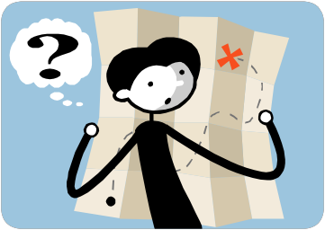

Project Worth Statement
What did you learn or enjoy in the project this year?

What project related skill(s) would you like to learn or improve?

Has this project been worthwhile to you? Why or why not?

Revised 11/2006

