WINNEBAGO COUNTY

FOODS & NUTRITION/FOOD PRESERVATION PROJECT RECORD FOR 20____

Things I plan to do and learn this year in this project are: (complete this box between Jan. 1 — May 1) | Check When Done

CHECK SKILLS LEARNED OR IMPROVED
Reading a recipe |  |  | Marinating meat
Measuring liquid & dry ingredients |  |  | Use My Plate
Handle knives |  |  | Prepare complete meal
Use measuring spoons & cups |  |  | Plan party/special event
Use electric mixer |  |  | Pack a safe lunch
Use blender |  |  | Explore ethnic foods
Baking |  |  | Eat healthy foods
Broiling |  |  | Food preservation
Frying, sautéing |  |  | Use pressure canner
Steaming, boiling, poaching |  |  | Follow canning process directions
Chopping, dicing, slicing |  |  | Use proper containers
Grating, shaving |  |  | Know purpose of blanching
Peeling, paring |  |  | Use proper drying techniques
Label reading |  |  | Use proper freezing techniques
Product comparison |  |  | Other: (Please List)
Table setting
Menu planning
Modifying recipes for health
Garnishing

FOOD PREPARED AND SERVED

Food prepared this year. Comment on things learned as you prepared each food.
Food Prepared | Times  Made | Easy/ Hard | Comment

What project related skill(s) would you like to learn or im- prove?
Exhibits in This Project:

(additional page may be added)
Item | Placing

List at least 2 foods industry related careers that you can identify.

Are you interested in a career related to the foods industry?

Yes No Maybe

Ways You Received Help This Year Include:
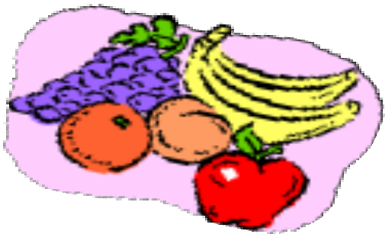
(check all that apply)

Attended project training offered by my club
Attended project training offered at the county level
Attended project training offered at District or State Level
Guidance from 4-H Leader/4-H Club
Guidance from Parent/Guardian/Other Adult
Reading and use of 4-H project guides
Reading and use of literature, books, audio visual resources
Own knowledge
Help from friends/other youth
Other (describe)

Project worth Statement

Has this project been worthwhile to you? Why or why not?

Revised 10/2019

