WINNEBAGO COUNTY

DOG PROJECT RECORD FOR 20

Things I plan to do and learn this year in this project are: (complete this box between Jan. 1 — May 1) | Check When Done

Ways You Received Help This Year Include:
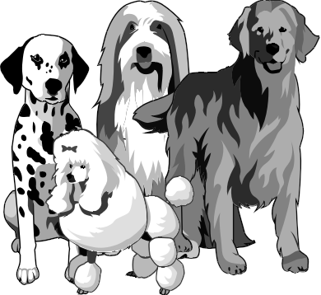(check all that apply)

Attended project training offered by my club
Attended project training offered at the county level
Attended project training offered at District or State Level
Guidance from 4-H Leader/4-H Club
Guidance from Parent/Guardian/Other Adult
Reading and use of 4-H project guides
Reading and use of literature, books, audio visual resources
Own knowledge
Help from friends/other youth
Other (describe)

What did you learn or enjoy in the project this year?
What project related skill(s) would you like to learn or improve?

List at least 2 dog industry related careers that you can identify.
Describe what you learned or improved by attending dog training classes.

Are you interested in a career related to the dog industry?
Yes_ No_ Maybe_

Information About Your Dog
(choose only 1 dog)

My Dog‘s Name is Sex: Male Female

Age of Dog
Date of Birth Has your dog been altered/spayed Yes No

Breed of Dog Purebred Cross Bred

Who Owns the Dog?

Date of: | Rabies Shot |  | How often
 | Distemper Shot |  | do you: | Bathe your dog
 | Hepatitis Shot |  |  | Cut its toe nails
 | Parvo |  |  | Brush its teeth
 | Heartworm Test

Project Worth Statement—Has this project been worthwhile to you? Why or why not?
Record of Veterinary and Other Expenses
Item | Cost
License | $
Food & Treats | $
Toys | $
Training Expenses | $
Veterinary Expenses | $
Vaccinations | $
Other Equipment & Supplies:
 | $
 | $
Total | $

Exhibit Record

In what ways did you exhibit your dog?
Fun Match Demonstrations Other, describe
Sanctioned Match State Dog Show
County Fair Club Event
Date | Name of Show | Class Entered | No. in Class | Placing

Revised 11/2006

