WINNEBAGO COUNTY

CLOTHING PROJECT RECORD FOR 20

Things I plan to do and learn this year in this project are: (complete this box between Jan. 1 — May 1) | Check When Done

CHECK SKILLS LEARNED OR IMPROVED

Selecting/using sewing equipment Selecting & preparing fabrics
Reading & using patterns
Learning parts of a sewing machine Clipping, seam finishes
Pressing & clothing care Selecting accessories Planning wardrobe
Alteration or mending clothing article Applique
Using fleece or other specialty fabric
Sewing darts, pleats, or interfacings
Facings
Zippers
Collars & cuffs Hems Fasteners
Buttons/buttonholes
Top/under stitching
Matching plaids, stripes, and designs Quilting
Exploring related careers/jobs Embellishments on article
Serging

Ways You Received Help This Year Include:
(check all that apply)
Exhibits in This Project:
Item Placing
(additional page may be added)

Attended project training offered by my club
Attended project training offered at the county level
Attended project training offered at District or State Level
Guidance from 4-H Leader/4-H Club
Guidance from Parent/Guardian/Other Adult
Reading and use of 4-H project guides
Reading and use of literature, books, audio visual resources
Own knowledge
Help from friends/other youth
Other (describe)

INDIVIDUAL ARTICLE RECORD
Choose (1) item to report on in this project, please include pictures of all items on additional page.

Item made:
Attach fabric sample Fiber content

Approximate hours to make: hours

Cost To Make Article

Pattern $ Fabric $ Interfacing $ Notion(s) $

$

$

$

$

Total Cost $

What new skill, techniques, or information did you learn or improve by making this article?

Cost of comparable ready-to-wear
article $

List at least 2 clothing industry related careers that you can identify.

Are you interested in a career related to the clothing industry?
Yes_ No_ Maybe_
In comparing this home sewn article with a comparable ready-made do you feel this article was worthwhile to make rather than to buy?

Yes No Undecided

How will you care for your article?
Describe your primary intended use(s) for this article.

Project Worth Statement

Has this project been worthwhile to you? Why or why not?

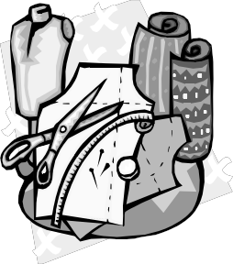Revised 11/2006

