WINNEBAGO COUNTY

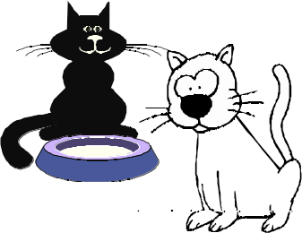CAT PROJECT RECORD FOR 20

Things I plan to do and learn this year in this project are: (complete this box between Jan. 1 — May 1) | Check When Done

Information About Your Cat

My cat's name is
Sex: Male Female

Has your cat been altered? Yes No
Age of Cat
Date of Birth

Project Expenses
Date |  | Cost/Value

Breed of Cat Purebred Crossbred

Who owns the Cat?

Tell how you got your cat. Did you buy the cat, get it from a friend or at the animal shelter? If you picked it out, why did you pick this cat?

Health Care
Date |  | Cost
 | Deworming pills
 | Flea collar or spray
 | Ear mite medicine
 | Q-tips
 | Other:

Ways You Received Help This Year Include: (check all that apply)

Attended project training offered by my club Attended project training offered at the county level Attended project training offered at District or State Level Guidance from 4-H Leader/4-H Club
Guidance from Parent/Guardian/Other Adult

Reading and use of 4-H project guides

Reading and use of literature, books, audio visual resources

Own knowledge

Help from friends/other youth

Other (describe)
Exhibits in This Project:
Item Placing
(additional page may be added)

List at least 2 cat pet industry related careers that you can identify.
What did you learn or enjoy in the project this year?

Are you interested in a career related to cats?
Yes_ No_ Maybe_

What project related skill(s) would you like to learn or improve?

My Cat is Special Because:
(Tell any tricks, habits, favorite toy, way of sleeping, or anything you think makes him/her special)

Project Worth Statement

Has this project been worthwhile to you? Why or why not?

Revised 11/2006

