WINNEBAGO COUNTY

BEEF PROJECT RECORD FOR 20

Things I plan to do and learn this year in this project are: (complete this box between Jan. 1 and May 1) | Check When Done

What did you learn or enjoy in the project this year?
What project related skill(s) would you like to learn or improve?

List at least 2 livestock industry related careers that you can identify.

Are you interested in a career related to the livestock industry?

Ways You Received Help This Year Include:
(check all that apply)
Exhibits in This Project:
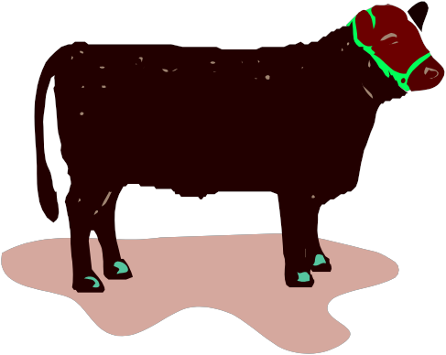Item Placing
(additional page may be added)

Attended project training offered in the county
Attended project training offered at District or State Level
Guidance from 4-H Leader/4-H Club
Guidance from Parent/Guardian/Other Adult
Reading and use of 4-H project guides
Reading and use of literature, books, audio visual resources
Guest presenters
Own knowledge
Help from friends/other youth
Other (describe)

INDIVIDUAL ANIMAL RECORD
Mark which animal(s) you will be reporting on: Market and/or Breeding Stock

Market Steer Estimated Feeding Plan
Choose (1) market animal to report on, please include pictures on additional page. If no market animal was exhibited, skip this section.

Animal’s Name/Identification:

1. Date of purchase:
and/or Date of birth:

2. Weight at Start of Project : (Spring weigh-in)
Date: _

3. Projected finish weight: Net projected gain:

4. Date of entry day at county fair:
weight.)
(This is the date of projected final market

5. Number of days from project start date to entry day:

6. Average daily gain will need to be pounds per day to reach planned finish weight.

7. Actual weight on entry day of county fair: Actual net gain:

8. Actual rate of gain (net gain ÷ number of days from start to finish):

9. How does this rate of gain compare to current beef industry performance standards?

Low
Near
High
Explain:

Breeding Stock Report
Choose (1) breeding female to report on. Please include pictures on an additional page. If no breeding stock was exhibited, skip this section.

Animal’s Name/Identification:

1. Breed:

2. Date of Birth:
Management Practices Vaccination/deworming Dates: Product used: Hoof trimming dates: Describe your feeding program:

3. Sire:

Dam:

4. Is your heifer/cow bred? _Yes _No

If yes, to which bull?

Project Worth Statement

Has this project been worthwhile to you? Why or why not?

When is she expected to calve?

5. Why did you choose this mating?

Revised 03/2006

